OSHA COMPLIANT LOADING BRIDGE FALL PROTECTION
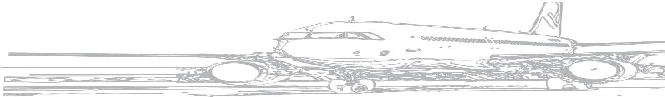

Airport Bridge Company, Inc. East Island Aviation Services, Inc.
Manufacturing & Installation Global Sales & Market Development
FEATURES
- Dual lifelines for Two Mechanics Meets all applicable OSHA standards
- No moving parts Most cost effective solution on the
- Easy one day Installation market and ready to ship today
- Mounts on any Passenger Bridge Stainless steel & aluminum construction

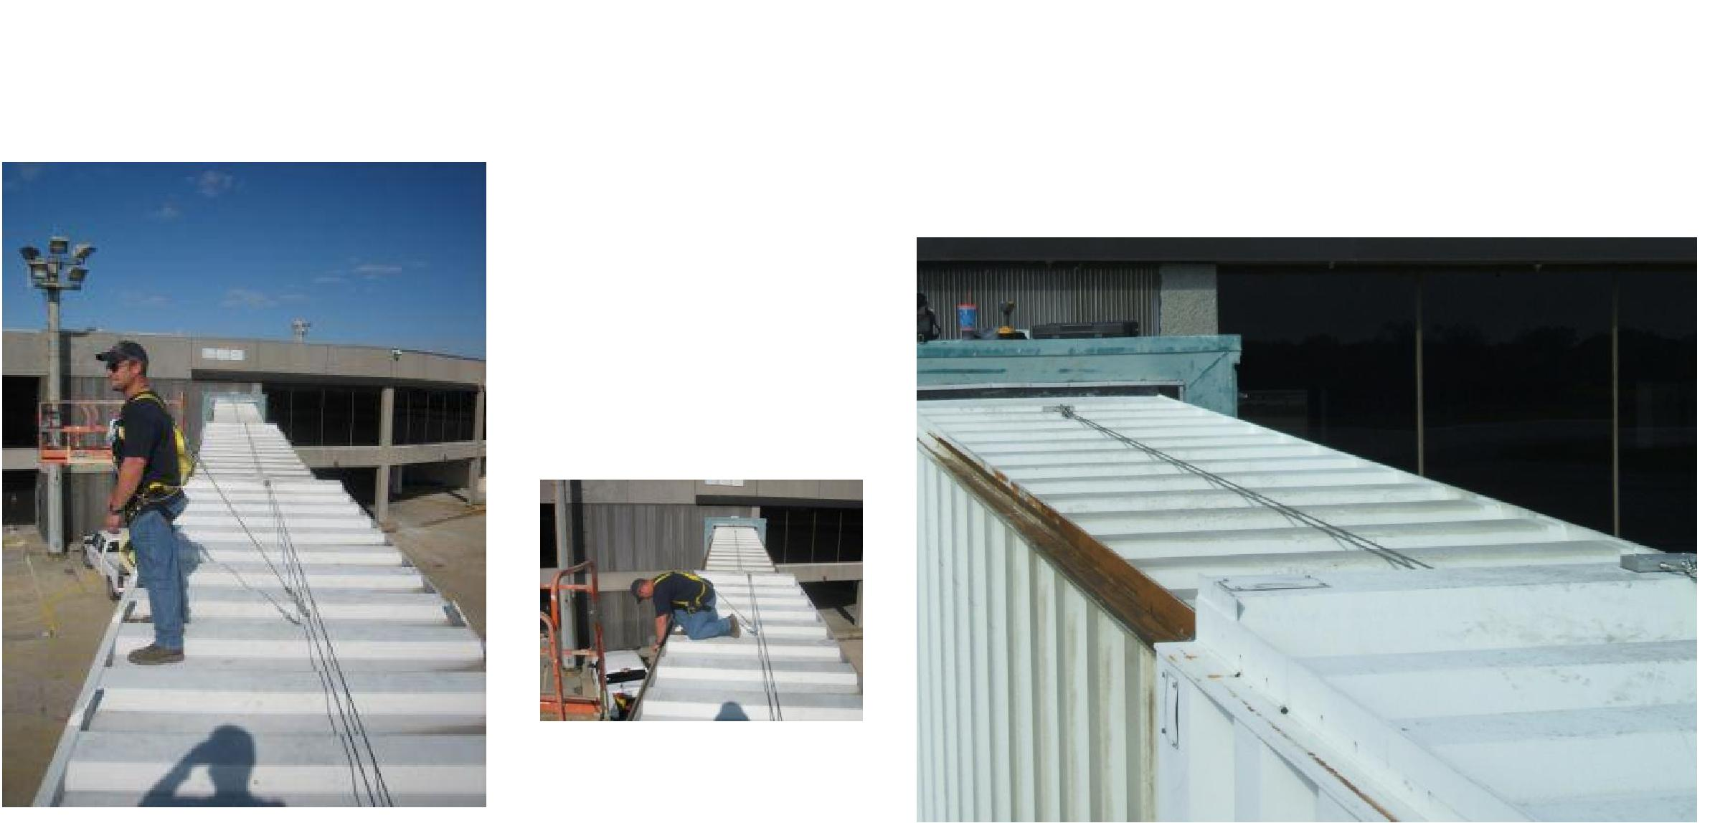
Safety First! Fall Protection is critical when technicians are required to complete tasks that could potentially result in injury. Our Fall Protection System was designed with the user in mind. Clip on and Go! Unlike other systems it requires only minimal training and requires no set-up or pre-assembly. The simplicity of the system encourages users to comply. Not only do your technicians feel safe, they are safe. Attachment to the lifeline by one single
lanyard offers the most unrestricted mobility of any system available. Maintenance
consists of little more than visual inspections.
Simplicity at its best!

Compliance Reviewed per OSH Standard 29 CFR 1926.500
Reviewed to be complainant with OSHA’s construction fall protection regulations found in 29 CFR 1926.500 through 29 CFR 1926.503.
(OSHA’s 29 CFR 1926.500 fall protection regulations DO NOT apply to general industry applications). Maintenance operations in the
airline industry are generally covered by the regulations found in 29 CFR 1910

Feel free to ask for a copy of our independent evaluation and certification by FDR Safety, Inc.
Patent Pending
All rights reserved. Neither this publication nor any part of it may be reproduced, stored in a retrieval system, or transmitted in
any form or by any means, electronic, mechanical photocopying, recording or otherwise, without prior permission of East Island Aviation Services, Inc.
and Airport Bridge Company.
To order, contact either company below:
East Island Aviation Services, Inc. Airport Bridge Company, Inc.
18 W. Carver Street, Suite 1 19094 Old Covington Hwy.
Huntington, NY 11743 Hammond, LA 70403
(631) 385-0300 (985) 542-1705
Don Kelley direct (516) 443-4591 Leonard Triche direct (985) 351-0837

